EMR-7.2.0 Documentation process and issues

As part of the EMR version upgrade for products we have worked on the testing of upgrading the DS to EMR-7.2.0 version.

set HTTPS_PROXY=http://pitc-zscaler-aspac-bangalore3pr.proxy.corporate.ge.com:80
gossamer3 -a default bulk-login .gossamer3_roles.yml --aws-urn=urn:amazon:webservices:mfa
Git Branch: datasci-graviton-emr7
ganglia service is not supportive in EMR-7.2.0 version
DS-7.2.0 Non-Prod
============================================================================
aws --no-verify-ssl cloudformation deploy --stack-name datasci-cluster7-v01-emr-cicd-pipeline --template-file av-cicd-pipeline-master_v2.yaml --parameter-overrides UAI=UAI3038827 env=datasci-dev Name=datasci-7.2.0 product=datasci ApplicationPrefix=datasci GitHubURL=https://github.build.ge.com/AviationDAAS/emr-platform TeamDistributionList=503140132@ge.com KMSKey=arn:aws:kms:us-east-1:958262988361:key/7900f70a-f9bc-4e2d-839a-0813fb11fb29 TemplateConfig=true GitBranch=datasci-graviton-emr7 TemplateConfigFile=datasci-cluster-6-params.json BuildSpec=buildspec_v2.yaml ProdConditional=true S3FilesProd=true S3FilesProdCustomPrefix=emr/bootstrap Template=template-v2.yaml ChangeSets=true DashBoardStageConditional=true DashBoardProdConditional=true --s3-bucket med-av-daas-preprod-datasci-cicd --s3-prefix Datasci-cicd-template --profile 958262988361/av-bu-datasci-dev

"Ec2KeyName": "{{resolve:ssm:/cicd/ec2-key-pair-name:1}}",
"Ec2KeyName": "platform-test-local"

Issue 1: 2FA authentication Failed
As the EMR-7.2.0 with AWS default AMI uses the AL3 kernel, faced the issue with Nix login to the server.
After verifying and troubleshooting we found that pam radius package is not executing in Bootstrap action script.
Created AWS support case CASE 172960819100782
EMR-7.2.0 Cluster: 2FA Authentication Failed

Based on the discussions suspected that the PAM raidus package pam_radius-1.4.0-17.amzn2.aarch64 is not supportive in AL3.

"pam_radius" package was removed from linux 2023
https://github.com/amazonlinux/amazon-linux-2023/issues/467
https://docs.aws.amazon.com/linux/al2023/release-notes/removed-AL2023.6-AL2.html
We have used the below commands to install pam radius which is responsible for 2FA authentication.
After installing the pam-radius package and starting the sssd service we got "TLS unsupported protocol" error.
The TLS version that we are using in our LDAP is TLSv1.0 need to upgrade higher versions which are compatible with AL3 servers.
As per suggestions given by the unix management team made some modification in 2fa and sssd.conf file.
After the changes 2fa script is working fine and able to login using NIX ids.
Below are the tracking steps to mitigate the issue.

Step 1: Identified issue with Pam Radius package and openssl lib11.
The Pam Radius and openssl lib11 packages is not installed in AL3
Pam Radius package was removed in AL3 which is responsible for 2FA authentication.
Installing the Openssl lib11 package got the “Unable to find a match: openssl11-libs” error
We have connected with AWS Support team installed Pam Radius and openssl lib11 externally using the installation commands
https://dl.fedoraproject.org/pub/epel/epel-release-latest-8.noarch.rpm

Step 2: Created AWS Support case 172960819100782
Not able to login to server with nix users. 2Fa Authentication is failed.
After verifying and troubleshooting we found that pam radius package is not executed in Bootstrap action script.
Created AWS support case CASE 172960819100782.
After Troubleshooting and discuss with the AWS Support team concluded that TLSV1.0 version is not supported for AL3 need to upgrade it with compatible version.

Step 3: EMR-7.2.0 comes with AL3 linux version.
Amazon EMR 7.2 introduces Amazon Linux 2023 (AL3) as its default operating system for clusters.
This is a significant update, as it brings improvements in performance, security, and stability compared to the previous Amazon Linux 2 (AL2). AL3 is designed specifically to optimize workloads in the cloud, offering better integration with AWS services and modern features like more frequent updates and enhanced security capabilities.

Key highlights of EMR 7.2 with AL3 include:

Improved Security: AL3 brings more frequent security updates and features such as enhanced support for containerized workloads.
Better Performance: AL3 is optimized for better performance on AWS infrastructure.
Long-term Support: AL3 offers extended maintenance support, ensuring a stable environment for running big data applications on EMR.

Step 4: Created Ticket with unix management team
As the ldap hosts are not able to do telnet
Created ticket with unix management team on issue facing the 2FA authentication failed in LDP.

Step 5: conf details to unix management team.
Unix Management team has requested to provide the .conf files and information as they don’t have access.
Provided all the .conf files in zip archive format as requested by the unix team.
server is not communicating with our ldap at all. telnet corpldapvipcin.ldap.ds.ge.com 636 is getting connection refused.

Step 6: Unix team suggested to check with port 636 for the new ldap vds servers
We have checked with the Unix team with LDAP Urls and we have created RITM Ticket and FRA ticket they have concluded the solution and they asked to Created the ticket.
Step 7 : Created FRA: FRA0080361 and RITM: GERITM48577105 for the same with @CORP CISO Approvers team
Request Firewall Port 636 (TCP) for LDAP Unable to Open port receiving Timeout error
Step 8: CR has been created for the above FRA for implementation GECHG2209313 with @CORP Global Network OPS Firewall
Your request for change GECHG2209313 with brief description" <FW> Firewall Rule Add Change" has been successfully implemented.
Source 10.93.217.222/10.73.238.46/10.137.38.18 Destination 10.230.246.0/24
Step 9: After the implementation still having issues with telnet.
After implementation successfully we have testged from our end again the issue is e are getting the TIMEOUT issue
Step 10: Verified with Corresponding team and created new FRA as the Destination and source need to be changed
As they have metioned earlier need to change the destination and source we have changed and tested the FR implementation
Step 11 : New FRA: FRA0080508 and RITM GERITM48668185 has been created.
We didn’t see any changes resolved we have created FRA request for better solution.
Step 12 : Source 10.230.246.0/24 Destination 10.93.217.222/10.73.238.46/10.137.38.18
We have Transpose the Source and Destination IP’s and Implemented changes.
Step 13: 636 ports have be opened after the change implementation
After Transpose of the Source and destination FR 636 opened successfully
Step 14 : Perfromed the post implementation testings for connectivity and working as expected.
We have tested with command telnet corpldapvipalp.ldap.ds.ge.com 636 for testing working as expected
Step 15: Had issues with certificates and after changing the location in sssd conf working as expected and able to login using Nix ID
We were able to Login with Hadoop after changing the ssd conf file we were able to login with Nix ID’s.
Below are the changes that are made in graviton2fa_emr7.sh

Commands to install Pam_radius package:
- wget https://dl.fedoraproject.org/pub/epel/epel-release-latest-8.noarch.rpm .
- rpm -ihv --nodeps ./epel-release-latest-8.noarch.rpm
- yum install pam_radius -y
- rpm -qa | grep pam_radius

Issue 2: Fetching Meta data

Added New metadata commands:
Added new metadata commands to fetch details.
TOKEN=`curl -X PUT "http://169.254.169.254/latest/api/token" -H "X-aws-ec2-metadata-token-ttl-seconds: 21600"`
INSTANCE_ID="`curl -H "X-aws-ec2-metadata-token: $TOKEN" http://169.254.169.254/latest/meta-data/instance-id`"
REGION="`curl -H "X-aws-ec2-metadata-token: $TOKEN" http://169.254.169.254/latest/meta-data/placement/availability-zone | sed -e 's:\([0-9][0-9]*\)[a-z]*\$:\\1:'`"

Added the same metadata commands in below scripts:
- addhdfsuser_emr7.sh
- addhome_emr7.sh
- datasci-BootstrapActionScript_graviton_emr7.sh
- datasci-SecondaryBAScript_graviton_emr7.sh
- cluster_check_list_emr7.sh
- cluster_validation_report_emr7.sh

Issue 3 with Zeppelin Service:
Built Non Prod cluster and validated, zeppelin service has been not came up, after troubleshooting found the fix and created AWS support case as well to understand if any changes in addition to the recommendations.
After troubleshoot all the issue were solved we build a Nin Prod cluster and validated. While Validating we have encountered some issue Zeppelin
Step 1 : After updating the recommended properties in zeppelin-site.xml and zeppelin-env.sh zeppelin service is up and running.
After troubleshoot we found the zeppelin-site.xml and we have made changes as per the recommendations the service were up and running as expected.
Step 2. Validated the interpreters and notebooks in the 7.2.0 Non prod cluster.
After zeppelin service is active we have validated the Interpreters and Notebooks in 7.2.0 cluster .
Step 3. Working on making the changes to the Git branch and creating cluster for end to end testing.
After troubleshoot and validating all the emr 7.2 cluster issues we have made the changes into the Github repo.And we have released the New test cluster for testing.
Changes made from existing files.
- Added new zeppelin-site_emr7.xml
- Added interpreter_emr7.json
- In zeppelin-site_emr7.xml we have added port, s3 sync, kms key region, Zepplin.server.addr
============== ====
<property>
<name>zeppelin.server.addr</name>
<value>0.0.0.0</value>
</property>

<property>
<name>zeppelin.server.port</name>
<value>8890</value>
<description>Server port.</description>
</property>

<property>
<name>zeppelin.notebook.s3.endpoint</name>
<value>https://s3.amazonaws.com</value>
<description>endpoint for s3 bucket</description>
</property>

<property>
<name>zeppelin.notebook.s3.kmsKeyRegion</name>
<value>us-east-1</value>
<description>AWS KMS key region in your AWS account</description>
</property>
==================

Issue 4:Cloudwatch metrics.
Setting up cloudwatch logs for mounts and memory.
CloudWatchMonitoringScripts that we were using before was not working in the AL23 , error that we were getting is unable to fetch ec2 meta data. And awslogs was not installing.
To resolve the issue installed amazon-cloudwatch-agent in which awslogs is installed by default. By installing cloudwatch agent metrics were pushing.
Added cloudwatchmetrics_emr7.sh file to push the metrics data and execute the file from datasci-SecondaryBAScript_graviton_emr7.sh bootstrap file.
By doing this we able to push all the disk and memory metrics of the instances of EMR 7.2 cluster.
- curl -O https://amazoncloudwatch-agent.s3.amazonaws.com/amazon_linux/arm64/latest/amazon-cloudwatch-agent.rpm
- # Install the CloudWatch Agent
- sudo rpm -Uvh amazon-cloudwatch-agent.rpm
- yum install collectd –y
- Setting up amazon-cloudwatch-agent-config-wizard with config.json

Issue 5:
cluster check report and cluster_validation_report were not fetching.
We have observed that Mailx and sendmail were not installed in AL23 because of that not getting mail of cluster check list.
Installed Mailx and send mail , now we are getting the mails.
Added below commands:
- echo "installing mailx commands"
- yum install mailx -y
- yum install sendmail -y
- sudo systemctl start sendmail
- sudo systemctl enable sendmail
- sudo systemctl status sendmail

Changes made in datasci-SecondaryBAScript_graviton_emr7.sh
- Added new files path addhdfsuser_emr7.sh, addhome_emr7.sh, cloudwatchmetrics.sh.
- Added commands to install mailx and sendmail.

Issue 6:
local.3.9.requirements_grv.txt is not executing completely and some packages are missing.
. While executing we found that there is a conflict between packages while installing.
Below are the packages which are not installed through requirement.txt
bkzep==0.6.1
openpyxl==3.0.10
boto3==1.24.34
koalas==1.8.1
psycopg2-binary
pytest
We observed that requests== 2.25.1 is already installed. So in requirement.txt we have commented the requests==2.28.1 and run the file, all the packages in requirement.txt file has been executed successfully.
We have also tried by installing requests by removing the version and we found out the conflict between requests and idna 3.3 is getting downgraded to idna 2.10
We have also observed that postgresql is installed by default.

Zeppelin Validation:
Spark.sql
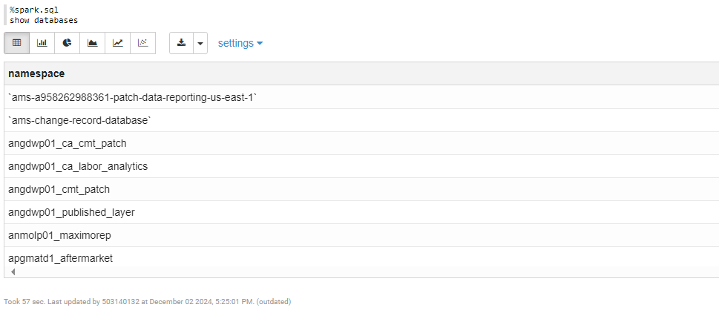

%spark_ceod_group_python3x.pyspark
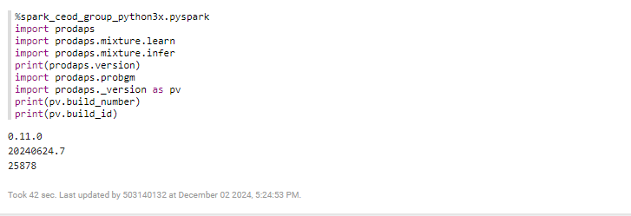
%ceod_group_python3x.pyspark
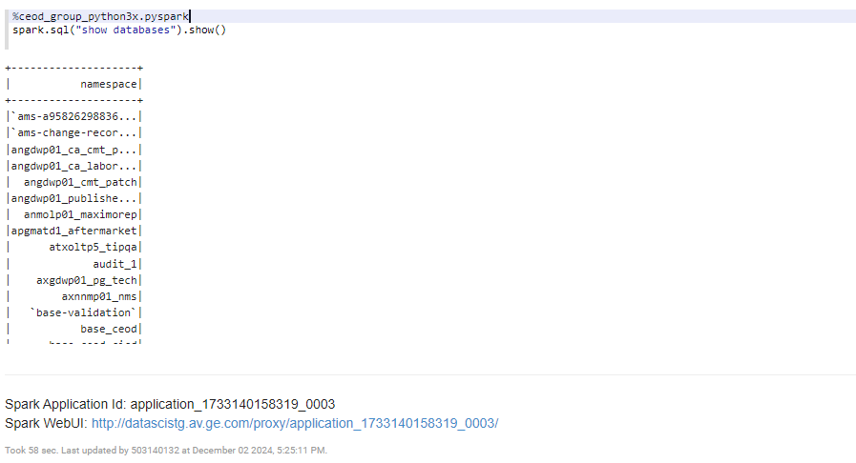

%ceod_group.sql
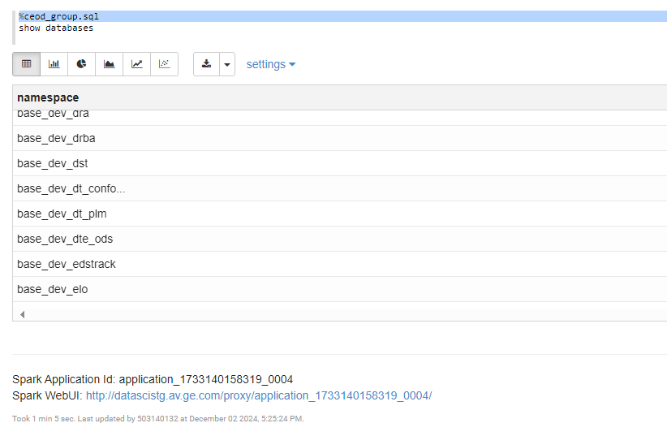
Spark
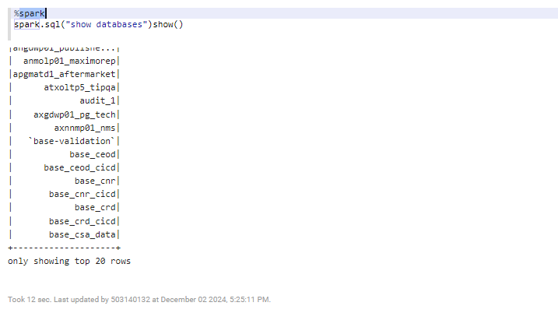

%ceod_group.pyspark
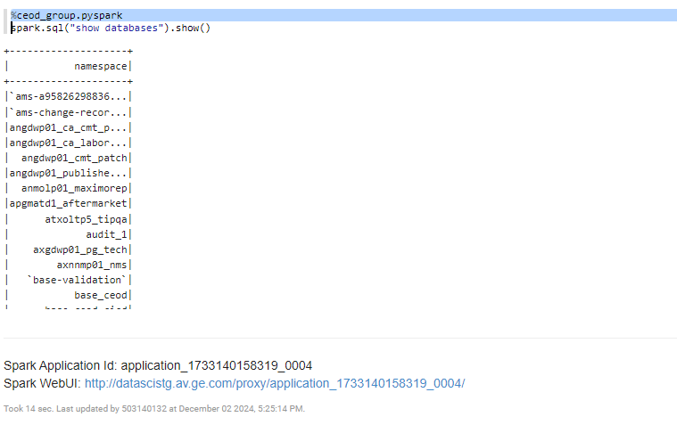
%spark_ceod_group_python3x.pyspark
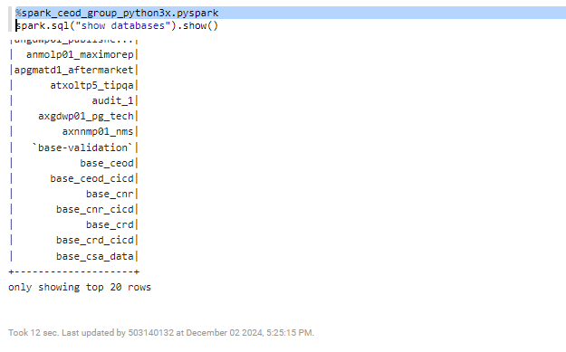

%spark_ceod_group_python3x.pyspark
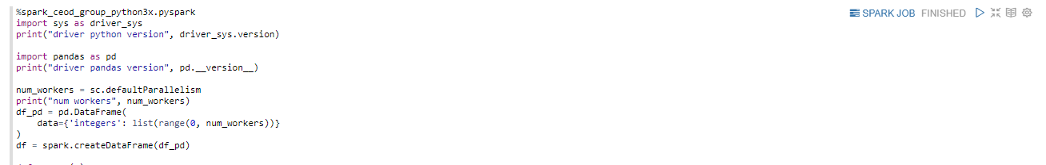

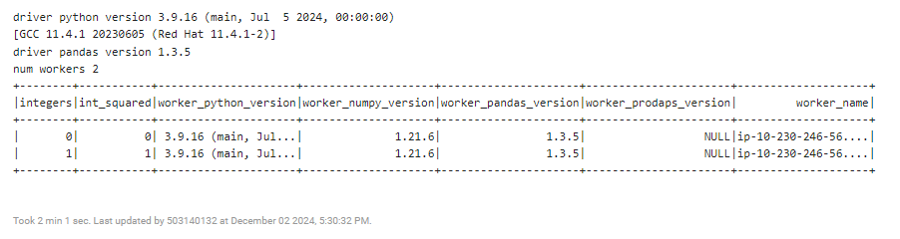
%spark_ceod_group_python3x.pyspark
